**OPEN A CINEMA IN SPAIN**

* **Introduction**

I want to recommend a location in the north of Spain to open a new cinema. The stakeholder wants to open a new cinema as company's new business. Cinema should has many restaurants and shopping places nearby. Transportation is also an important factor. Customer can walk to cinema within 5 minutes from public transport facilities is perfect. I concentrated on selection of cinema location according to its nearby environment. Cinema facility and rental price is not my concern. He lists out his top 10 favorite cinemas in northern Spain with rating and I select 5 possible locations to build the cinema.

* **Problem**

Data that might contribute to determining the best place to open a new cinema

* **Data acquisition and cleaning**

I obtain data from Google Maps and Foursquare.

I delete the duplicate data and only choose the information which I could use to solve the problem.

* **Feature selection**

After data cleaning, there were 65 samples and 5 categories in the data

* **Exploratory Data Analysis**
* **Relationship between categories**

Bus Stop, Food and Shop & Service seems more correlative

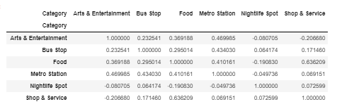

* **Importance of each category**

We can see which category is more representative around cinemas

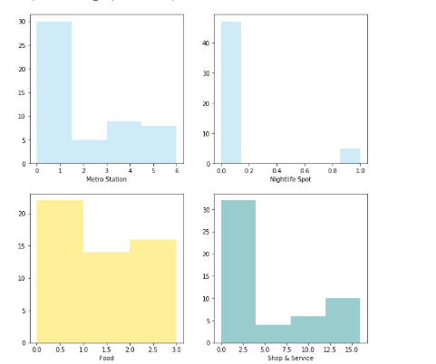

There are more number of shops and services than any other category

* **Best possible locations in those cities**

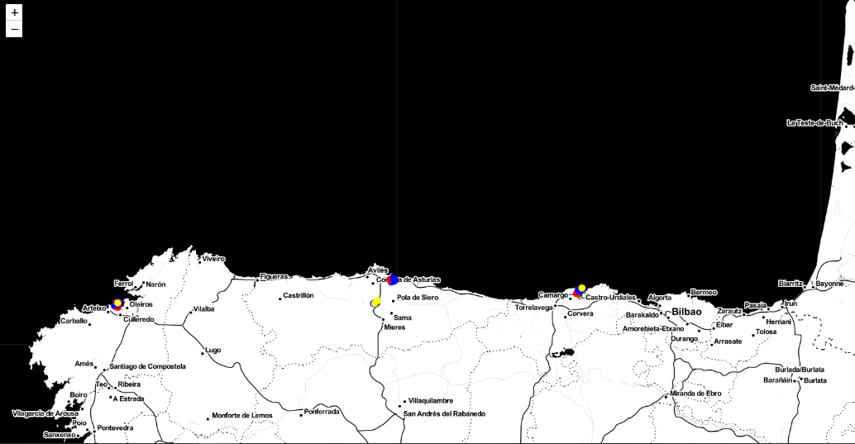

We can see in the map the best possible locations to build our cinema

* **Results**

Location “Gijon" has the most number of venues in category "Bus Stop", "Food", "Metro Station" and "Shop & Service“ and is the best place to open a cinema